
INVENTION DISCLOSURE FORM
For Patent Filings under the Indian Patents Act, 1970
and Corresponding Foreign Jurisdictions
IDF: NQ-001 · NeuralQuant Multi-Agent Equity Research System · Satyam Das · June 2026

Strictly Confidential · Governed by NDA between Satyam Das and Intepat IP Services Pvt Ltd

IDF Reference  IDF-NQ-001 | Filing Category  Natural Person as Individual Inventor | Target Office  Indian Patent Office (Kolkata / Eastern Region)
About this form
This Invention Disclosure Form (IDF) captures the essential facts about your invention so that Intepat IP can evaluate patentability and prepare the patent application. Please describe what you have built, what problem it solves, and how it works, in your own words, using plain language. The quality of the resulting patent specification depends directly on the clarity and completeness of what you provide here.
How to fill this form
Replace the grey italic prompts in each box with your own content. Sections expand naturally as you type. Paste diagrams, screenshots, and drawings directly into the designated spots, Word will embed them in the document. Once complete, save the file (password-protect it if you wish) and email it as a single self-contained document to your designated Intepat patent agent, or to patent@intepat.com.
Confidentiality
All information disclosed herein is treated as strictly confidential by Intepat IP Services Pvt Ltd and is governed by the Non-Disclosure Agreement executed between the parties. By submitting this form, the inventor(s) acknowledge that the information is shared in confidence solely for the purpose of patent evaluation and prosecution.

1. GENERAL INFORMATION
1.1 Title of the Invention
A Computer Implemented System and Method for Generating Regime-Adaptive Multi-Factor Equity Research Signals Using a Multi-Agent Adversarial Debate Framework
NOTE: The title is intentionally framed as a technical system producing a measurable technical effect (regime-adaptive signals), to satisfy CRI Guidelines 2025 requirements. The title must NOT reference “hallucination suppression” or “LLM grounding” as the primary framing — that is a secondary feature. The primary inventive contribution is the regime-adaptive quantitative architecture combined with the adversarial debate synthesis.

1.2 Field of the Invention

Broad Field | Artificial Intelligence applied to Financial Technology (FinTech); Quantitative Finance; Multi-Agent Systems
Narrow Field | Regime-adaptive quantitative factor scoring engines combined with multi-agent large-language-model adversarial debate frameworks for automated equity research; dual-market (India NSE + US NYSE/NASDAQ) investment signal generation accessible to retail investors
CPC Classification (suggested) | Primary: G06Q 40/06 (Investment, e.g. mutual funds or pensions); Secondary: G06N 20/00 (Machine learning); G06N 5/04 (Inference or reasoning methods); G06F 40/56 (Fact verification / grounding). Note to agent: G06Q40/06 should be primary to anchor in finance, not NLP

1.3 Keywords
multi-agent AI, adversarial debate framework, PARA-DEBATE, regime-adaptive factor model, Hidden Markov Model, market regime detection, Piotroski F-Score, Jegadeesh-Titman momentum, quantitative equity research, IRS% investment readiness score, NSE Bhavcopy, delivery percentage signal, India VIX, dual-market financial analysis, retail investor research, LLM orchestration, hallucination suppression, numeric reconciliation, provenance-tagged data, real-time market data, India + US equity markets

2. CRITICAL DATES (THE “BAR” DATES)
Public disclosure of the invention before filing can destroy novelty in most jurisdictions. Please be exhaustive, include written, oral, online, and private-to-third-party disclosures.
ATTORNEY PRIORITY NOTE: India operates an absolute novelty standard under Section 2(1)(l) of the Patents Act 1970. However, Section 31 read with Rule 29A and Form 31 (Patent Amendment Rules 2024) provides a 12-month grace period from the inventor’s own public disclosure. Form 31 MUST be filed with the provisional application to formally avail this grace period
2.1 Past Disclosures
Has the invention been disclosed to anyone outside your organisation before today? This includes publications, conference talks, posters, blog posts, GitHub commits, demos, investor pitches, grant applications, vendor discussions, customer conversations.
☐☐☑ Yes ☐ No (detail below)
Platform launch: neuralquant.co | The NeuralQuant platform (neuralquant.co) is publicly accessible without login, currently at Version 4.0. The platform constitutes a full enabling disclosure of the multi-agent analysis system, IRS% scoring, PARA-DEBATE output, and dual-market coverage: first public availability 14 May 2026. This is the earliest likely disclosure date and anchors the grace period window.
/methodology page | The neuralquant.co/methodology page provides a detailed public description of the PARA-DEBATE six-analyst-plus-head-analyst architecture, the IRS% derivation methodology, the consensus mechanism, walk-forward validation approach, and the data pipeline. Published on 6 June 2026. This page constitutes an enabling disclosure of the inventive method.
GitHub repository | A public GitHub repository (github.com/satyamdas03/NeuralQuant) was accessible as of 23-03-2026, containing code relating to the system architecture. Current status: restricted.
LinkedIn | Personal LinkedIn profile posts have referenced the platform publicly. LinkedIn post-dated: 5 May 2026. None under NDA.
Live product demos | Live demos of the platform have been conducted.  Attorney to confirm whether any demo was ‘enabling’ in the patent sense.
NDA status | No NDA was in place for any of the above disclosures. All were public and unrestricted.

2.2 Upcoming Disclosures
Do you have any planned disclosure within the next 6 months, a conference submission, journal paper, product launch, pre-print upload, scheduled demo, or similar?
☐☑ Yes ☐ No (detail below)
Academic paper (arXiv + ACM ICAIF) | A research paper titled “PARA-DEBATE: A Multi-Agent Adversarial Debate Framework for Regime-Adaptive Quantitative Equity Research” is planned for submission to arXiv (cs.AI cross-listed to q-fin.PM) and ACM ICAIF 2026.  his paper will be submitted ONLY AFTER the provisional patent application number is received. The paper will include a patent pending footnote referencing the IPO application number. The paper will NOT disclose proprietary implementation parameters (factor weights, agent prompts, IRS% formula, delivery_pct normalisation). Only architectural concepts will be published.
Platform sale / acquirer diligence | The platform is being positioned for commercial sale (target acquirers: Indian fintech platforms, global AI fintech companies). Acquirer due diligence disclosures will occur under signed NDA. No technical architecture details will be shared prior to NDA execution. Patent pending status will be referenced in all sale materials.

2.3 Sale or Offer for Sale
Has the invention been sold, offered for sale, licensed, or used in commerce by you or anyone on your behalf?
☑ Yes ☐ No (detail below)

Commercial SaaS platform | NeuralQuant is live at neuralquant.co with published subscription tiers: Free (limited), Investor at USD 9.99/month (INR 499/month), Pro at USD 29.99/month (INR 999/month). Stripe payment infrastructure is being activated. The platform has live registered users.
Planned full asset sale | The inventor intends to sell the platform, codebase, custom domain (neuralquant.co), brand, user base, social handles (@neuralquant), and all associated IP, including this patent application, to a third-party commercial acquirer in a single clean transaction. Patent assignment to the buyer will be executed via Form 16 at IPO upon sale close.
Non-compete scope (for sale agreement) | Non-compete to be limited in scope: ‘AI-powered quantitative equity research platforms for retail investors’, maximum 2 years. Inventor’s career is in AI/ML research; overly broad non-compete would be prejudicial.
3. TECHNICAL DETAILS
3.1 Background & Prior Art, the “Old Way”
Current state, how the problem is currently solved
Retail investors in India and the US currently rely on one of the below categories of tools, each with structural deficiencies:
• INSTITUTIONAL PLATFORMS (Bloomberg Terminal at USD 2,000/month, FactSet at USD 24,000/year): Provide deep quantitative data but are financially inaccessible to individual retail investors. No AI-native multi-agent reasoning layer. No adversarial debate synthesis.
• QUANTITATIVE SCORING TOOLS (Danelfin, Kavout K-Score, TipRanks, Seeking Alpha Quant): Output single composite scores from statistical models. No natural-language reasoning. No multi-perspective adversarial scrutiny. No dynamic regime-based factor reweighting. No India (NSE/BSE) market coverage.
• GENERAL-PURPOSE LLMs (BloombergGPT, ChatGPT, Claude applied to finance): Single-model, single-pass analysis. No live market data integration. Hallucinate or use stale numeric values. No multi-agent adversarial cross-examination. No regime-based quantitative scoring.
• MULTI-AGENT RESEARCH FRAMEWORKS (FinCon NeurIPS 2024, TradingAgents arXiv 2024, MarketSenseAI 2.0, AlphaAgent): Research prototypes only, not commercially deployed. US markets only, no India coverage. No HMM regime detection. No dynamic factor reweighting. No structured adversarial debate agent role.
Key deficiencies of all existing solutions
• No platform combines live quantitative factor analysis with adversarial multi-agent AI reasoning.
• No platform serves both Indian (NSE/BSE) and US (NYSE/NASDAQ) in a single unified AI-native framework.
• No existing tool incorporates NSE Bhavcopy delivery_pct as a live India-specific liquidity conviction signal.
• No existing retail platform applies HMM-based market regime detection to dynamically reweight quantitative factors.
• LLM-based tools hallucinate numeric financial data with no correction mechanism.
• Institutional-grade analysis tools cost USD 2,000–24,000/year; no product delivers equivalent analytical depth at a retail price point.

Reference documents, known similar patents or products
Known prior art references | Distinguishing features vs NeuralQuant invention
FinCon (NeurIPS 2024) | Multi-agent LLM for financial decisions. US markets only. No quant factor engine. No HMM regime detection. No adversarial agent role. No India market.
TradingAgents (arXiv 2024) | Multi-agent LLM trading framework. No quantitative scoring engine. No India market. No regime-adaptive weighting. No provenance-tagged data reconciliation.
MarketSenseAI 2.0 | LLM agents for stock analysis. US-focused. No 5-factor model. No HMM. No dual-market.
AlphaAgent | LLM alpha-mining system. No adversarial agent. No regime detection. No India market.
AutoGen (arXiv:2308.08155) | General multi-agent framework. No financial domain specificity. No quantitative scoring. No adversarial debate protocol.
Improving Factuality via Multi-Agent Debate (arXiv:2305.14325) | Academic paper on LLM debate for factuality. General domain. No financial factor engine. No regime detection. No numeric reconciliation against live data.
BloombergGPT (Wu et al., arXiv:2303.17564) | Finance-domain LLM. Single-model. No multi-agent. No regime detection. No India market.
Danelfin / Kavout | AI stock scoring. US markets only. Single-composite-score output. No adversarial debate. No regime-adaptive weighting. No India market.
Applicant's own public disclosures | neuralquant.co and /methodology page must be disclosed and covered by Form 31 grace period claim..

3.2 Summary of the Invention, the “New Way”
The invention is a computer-implemented system and method that delivers institutional-grade quantitative equity research to retail investors by uniquely combining two co-operating technical subsystems operating on a live dual-market data architecture:
• THE IRS% REGIME-ADAPTIVE FIVE-FACTOR QUANTITATIVE SCORING ENGINE: A cross-sectional quantitative scoring system that applies five academically-grounded financial factors dynamically reweighted based on a Hidden Markov Model (HMM) market-regime classifier, to produce an Investment Readiness Score (IRS%) for each equity in the coverage universe. The HMM classifies the current market state into one of four discrete regimes (Risk-On, Risk-Off, Bear, Late-Cycle), and factor weights shift accordingly. For Indian equities, a sixth India-specific signal, the NSE Bhavcopy delivery_pct ratio - is incorporated as a liquidity conviction proxy unique to Indian market microstructure, not present in any comparable system.
• THE PARA-DEBATE MULTI-AGENT ADVERSARIAL DEBATE FRAMEWORK: Seven specialised AI agents operating in parallel asynchronous execution: six domain-specialist agents (Macro, Fundamental, Technical, Sentiment, Geopolitical, and an Adversarial ‘Devil’s Advocate’ agent) each independently analysing the target equity from a distinct analytical perspective, followed by a seventh Head Analyst synthesis agent that integrates the debated, reconciled inputs into a structured investment conviction narrative and final IRS% conviction adjustment.
• NUMERIC RECONCILIATION MODULE: An orchestrator-level step that intercepts each agent’s structured numeric assertions and reconciles them against a provenance-tagged authoritative real-time data layer ([VERIFIED] / [ESTIMATE] / [UNAVAILABLE] tags) before synthesis, correcting hallucinated or stale values. Observable production corrections include: current_price $4.97 corrected to $205.20; ROE 76.3% corrected to 0.8%; market_cap $97T corrected to $4.97B; beta 202.0 corrected to 2.2.
The three subsystems operate in concert: the IRS% engine produces a quantitative anchor score; the PARA-DEBATE agents evaluate both the quantitative score and the qualitative context through structured debate; and the reconciliation module ensures that all numeric inputs are verified before synthesis. The result is a factually grounded, adversarially tested, regime-conditioned investment research signal delivered in real time at a retail price of USD 9.99 per month analytical depth that was previously available only to institutional investors paying USD 2,000–24,000 per year.

3.3 Detailed Description, the “How”
Component architecture | Description
Component 1: Data Ingestion Layer | Parallel real-time data pipelines with a fallback cascade and provenance tagging:  PRIMARY: Financial Modeling Prep (FMP) API, US equity OHLCV, financials, insider transactions.  SECONDARY: OpenBB Platform / yfinance HTTP-proxy service. Note: OpenBB is AGPL-v3; insulated via a separate process / HTTP API boundary.  Attorney to confirm boundary is sufficient  TERTIARY: 30-minute snapshot cache (Supabase-hosted).  QUATERNARY: Nightly score cache.  INDIA-SPECIFIC: NSE Bhavcopy daily delivery data, provides delivery_pct (delivered quantity / total traded quantity) as a liquidity conviction signal unique to Indian equity microstructure.  MACRO LAYER: FRED (Federal Reserve Economic Data); India VIX series; RBI monetary policy data.  INSIDER DATA: SEC EDGAR Form 4.  PROVENANCE TAGGING: Every data field is tagged [VERIFIED], [ESTIMATE], or [UNAVAILABLE].  ZERO SYNTHETIC DATA POLICY: All inputs are live or recently cached real-world data. No simulated, synthetic, or back-filled values used
Component 2: HMM Regime Detection Module | A Hidden Markov Model (Hamilton, 1989; Baum-Welch EM algorithm) trained on rolling macro and price-action features classifies the current market state into one of four discrete regime states:  RISK-ON: Bullish, low volatility, growth-oriented. Factor weights: momentum and low-volatility factors elevated.  RISK-OFF: Defensive, rising volatility, flight-to-safety. Factor weights: quality (Piotroski) and value factors elevated.  BEAR: Declining market, high volatility. Factor weights: quality and value dominant; momentum de-emphasised.  LATE-CYCLE: Slowing growth, yield curve dynamics, inflation-sensitive. Factor weights: value and quality dominant. Rolling window: 6 months of daily data. Separate regime classifiers for Indian and US markets.
Component 3: IRS% Five-Factor Scoring Engine | A cross-sectional quantitative scoring engine computing five academically-grounded factors for each equity in the 1,000+ ticker coverage universe: FACTOR 1: PIOTROSKI F-SCORE (Piotroski, 2000): 9-point financial health signal;  FACTOR 2: JEGADEESH-TITMAN MOMENTUM (Jegadeesh & Titman, 1993): 12-month minus 1-month price return momentum signal, cross-sectionally ranked within sector peer group;  FACTOR 3: HMM REGIME STATE SIGNAL: Current market state classification used as a meta-factor anchoring the composite weight matrix;  FACTOR 4: VALUE COMPOSITE (Lakonishok, Shleifer & Vishny, 1994): Composite of sector-relative P/B, P/E, and EV/EBITDA ratios;  FACTOR 5: LOW-VOLATILITY FACTOR (Ang et al., 2006): 36-month beta-adjusted realised volatility; INDIA-SPECIFIC  FACTOR 6: NSE BHAVCOPY DELIVERY_PCT: Daily delivery percentage capturing institutional conviction buying vs. intraday speculation.  All factors sector-adjusted and cross-sectionally rank-normalised (0–100 percentile). Composite IRS% = weighted sum of normalised factor scores, weights from current HMM-detected regime state.
Component 4: PARA-DEBATE Adversarial Debate Framework | Seven specialised AI agents (Anthropic Claude via AWS Bedrock) operating in parallel via Python asyncio.gather():  AGENT 1: MACRO: Macroeconomic context from FRED data, India VIX, RBI policy.  AGENT 2: FUNDAMENTAL: Financial statement quality, Piotroski sub-scores, earnings quality.  AGENT 3: TECHNICAL: Price action, momentum signal quality, volume dynamics.  AGENT 4: SENTIMENT: News sentiment, analyst consensus, social signal context.  AGENT 5: GEOPOLITICAL: Country-level and sector-level risk factors.  AGENT 6: ADVERSARIAL (Devil’s Advocate)  KEY NOVEL ELEMENT. Systematically generates the strongest possible counter-case against the prevailing signals from Agents 1–5. Forces explicit engagement with downside scenarios. No comparable published multi-agent finance system includes a structured adversarial agent role.  AGENT 7: HEAD ANALYST (Synthesis): Receives verified, reconciled outputs of Agents 1–6. Synthesises into: (a) final investment conviction narrative; (b) bull/bear case structured summary; (c) key risk factors; (d) IRS% conviction adjustment; (e) recommended action and time horizon.
Component 5: Orchestrator + Numeric Reconciliation Module | An orchestrator intercepts the structured (JSON) output of each of Agents 1–6 after execution and before synthesis by Agent 7: EXTRACTION: Parses each agent’s structured output to extract all numeric assertions. COMPARISON: Compares each extracted numeric value against the [VERIFIED] fields. CORRECTION: Applies bounded corrections to any value that deviates from the verified figure beyond tolerance thresholds. Each correction is logged. AUDITABLE OUTPUT: The correction log is optionally surfaced in the user-facing report. OBSERVED PRODUCTION CORRECTIONS: current_price $4.97 corrected to $205.20; ROE 76.3% corrected to 0.8%; market_cap $97T corrected to $4.97B; beta 202.0 corrected to 2.2.  NOTE TO ATTORNEY: This component is a SUPPORTING FEATURE, not the primary inventive step.
Component 6: Dual-Market Data Architecture | A unified ticker universe of 1,000+ equities spanning NSE/BSE (India) and NYSE/NASDAQ (US) processed through a single scoring and debate pipeline, with market-specific data source routing: INDIA ROUTING: NSE Bhavcopy delivery_pct, India VIX heuristics, RBI policy overlay, BSE/NSE financial filings. US ROUTING: SEC EDGAR Form 4, FRED macro series, US VIX. REGIME DETECTION: Separate HMM classifiers for Indian and US markets. This is the first known commercially deployed platform to cover both NSE and NYSE/ NASDAQ with an AI-native quantitative research framework in a single unified pipeline.
Component 7: Output Assembly & Delivery | Real-time streaming delivery via Server-Sent Events (SSE) protocol. Tiered access: Free (limited queries), Investor (USD 9.99/month: full PARA-DEBATE output), Pro (USD 29.99/month, full output + API access). Response latency: 30–120 seconds end-to-end. Named product features: ‘Ask Morgan’ ForeCast; PARA-DEBATE deep-analysis (full 7-agent output); QuantAstra and Veronica voice assistants; Portfolio Intelligence module.

Step-by-step operation (method claim basis)
1. User inputs a target security ticker and receives a streaming analysis.
2. Data Ingestion Layer fetches live data from all relevant sources in parallel via the fallback cascade. Every field is tagged [VERIFIED], [ESTIMATE], or [UNAVAILABLE].
3. HMM Regime Detection Module classifies the current market state for the relevant market (Risk-On / Risk-Off / Bear / Late-Cycle).
4. IRS% Five-Factor Engine computes each factor score. Factor weights are loaded from the regime-conditional weight matrix. For Indian equities, NSE delivery_pct incorporated as Factor 6. Composite IRS% percentile score calculated (0–100).
5. PARA-DEBATE Framework initiates: all 6 specialist agents execute concurrently via asyncio.gather(), each receiving the full provenance-tagged data context and the preliminary IRS% score.
6. Orchestrator’s Reconciliation Module intercepts each agent’s structured JSON output. Extracts numeric assertions. Compares against [VERIFIED] fields. Applies bounded corrections. Logs all corrections. Corrected outputs passed to Head Analyst.
7. Head Analyst Agent (Agent 7) synthesises into: final conviction narrative, bull/bear cases, risk factors, IRS% conviction adjustment, recommended action.
8. Output streamed to user via SSE. Typical end-to-end latency: 30–120 seconds.

3.4 Novel Elements, the “Secret Sauce”
PRIMARY INVENTIVE CONTRIBUTION — the combination of elements (i) through (iv) constitutes the core invention. No prior art combining all four elements is known to the inventor
(i) PARA-DEBATE ADVERSARIAL DEBATE ARCHITECTURE WITH STRUCTURED DEVIL’S ADVOCATE AGENT | The systematic inclusion of a dedicated Adversarial Agent (Agent 6) that generates the strongest counter-case against prevailing signals from all other agents BEFORE Head Analyst synthesis is a novel architectural element not present in FinCon, TradingAgents, MarketSenseAI, or any other published multi-agent finance system. This prevents systematic bullish bias and forces explicit engagement with downside risk before a conviction signal is produced.
(ii) HMM REGIME-ADAPTIVE DYNAMIC FACTOR WEIGHTING | The use of a Hidden Markov Model to classify market regime state and dynamically reweight the five quantitative factors based on detected regime, so that the factor weight matrix shifts across Risk-On, Risk-Off, Bear, and Late-Cycle states — is a novel combination not present in any existing retail AI research platform.
(iii) NSE BHAVCOPY DELIVERY_PCT AS INDIA-SPECIFIC LIQUIDITY CONVICTION SIGNAL | The incorporation of NSE’s daily delivery percentage (delivered quantity / total traded quantity) from the NSE Bhavcopy as a quantitative factor in equity scoring is an India-specific microstructure signal not present in any comparable system.
(iv) INDIA + US DUAL-MARKET UNIFIED AI-NATIVE ARCHITECTURE | The deployment of a single coherent AI-powered quantitative research system covering both NSE/BSE (India) and NYSE/NASDAQ (US) with market-specific data routing, India-specific signals, and separate regime classifiers for each market — in a single commercially deployed platform — is not known to exist in any prior art.
SECONDARY INVENTIVE CONTRIBUTION (supporting feature, not primary inventive step):
REAL-TIME PER-AGENT NUMERIC RECONCILIATION | The orchestrator-level interception of each LLM agent’s numeric assertions, comparison against a provenance-tagged real-time data layer, and application of bounded corrections before synthesis, suppressing numerical hallucination in a multi-agent pipeline. This is a genuine technical contribution but is claimed as an advantage and supporting feature; the primary inventive step is the combination described in items (i)–(iv) above.
3.5 Best Mode
LLM backbone | Anthropic Claude family models (claude-sonnet-4-6) via AWS Bedrock. Alternative LLMs (GPT-4o, Gemini 1.5 Pro) are viable substitutes without departing from the inventive concept.
Primary data source | Financial Modeling Prep (FMP) premium API for US equity data. NSE Bhavcopy for India delivery data. FRED API for US macro. India VIX from NSE.
Fallback cascade | FMP primary OpenBB/yfinance HTTP-proxy secondary 30-minute Supabase snapshot cache tertiary nightly score cache quaternary.
Reconciliation implementation | Deterministic post-processing over each agent’s structured JSON output. Bounded correction keyed to fields. Correction log stored per analysis cycle in Supabase.
HMM implementation | hmmlearn library (BSD licence) with 4 hidden states. Baum-Welch EM training on 6-month rolling window of daily macro + price features. Separate models for India and US markets.
Backend | Python 3.11+ with FastAPI framework. Asynchronous agent execution via asyncio.gather(). Hosted on Render.com.
Frontend | Next.js 16. Server-Sent Events for streaming output. Hosted on Vercel.
Database / Auth | Supabase (PostgreSQL) for user management, analysis history, score cache. DuckDB for in-process analytical queries.
Infrastructure | Cloud-hosted CPU instances. No GPU required for inference. Target latency: 30–120 seconds per full PARA-DEBATE analysis.

3.6 Alternatives and Variations
• The LLM backbone may be any frontier language model (GPT-4o, Gemini 1.5 Pro, Llama 3, Mistral, or a mixture of models per agent) without departing from the inventive concept. The inventive step lies in the architecture, not the specific LLM.
• The number of debate agents may be varied. Minimum viable implementation: 3 agents (at least one domain analyst, one adversarial agent, one synthesis agent). The 7-agent configuration is preferred.
• The factor model may be extended (ESG factors, quality composites, earnings revision factors) or contracted (minimum 2 factors + regime signal). The regime-adaptive weighting mechanism is the inventive element, not the specific factor count.
• The HMM regime classifier may be substituted with alternative regime detection methods: Gaussian Mixture Models (GMM), threshold-based macro rule systems, or supervised classifiers.
• The dual-market architecture may be extended to additional equity markets (European, Japanese, ASEAN) without departing from the inventive framework.
• The reconciliation module’s correction methodology may use strict replacement, bounded tolerance, or confidence-weighted blending.
• The system may be deployed as a B2B API for embedding in third-party financial applications.
• The delivery mechanism may use REST API polling rather than SSE streaming.
• The reconcile-then-synthesise method may be applied to other numeric-fact-intensive domains (medical diagnostics, legal discovery, engineering specifications) beyond financial analysis.

3.7 Advantages
Price democratisation | Delivers analytical depth equivalent to a Bloomberg Terminal (USD 2,000/month) at USD 9.99/month, a 200x price reduction. Makes institutional-grade quantitative research accessible to 90M+ active Demat account holders in India and 150M+ retail investors in the US.
Demonstrated alpha | Q1 FY2027 backtesting shows 87%+ directional hit rate for IRS% top-quintile equities vs. the broader market index benchmark, using live historical data with no look-ahead bias.
Adversarial robustness | The Devil’s Advocate agent prevents systematic bullish bias, a structural failure mode of non-adversarial AI research systems.
India market coverage | First commercially deployed AI-native platform to incorporate NSE Bhavcopy delivery_pct as a live quantitative signal, addressing a critical research gap for the world’s fastest-growing retail investor base.
Regime responsiveness | Factor weights adjust dynamically to detected market conditions, reducing the static-model failure mode observed in fixed-weight factor systems during regime transitions.
Numerical accuracy | Reconciliation module suppresses LLM numeric hallucination in production. Observed corrections: current_price $4.97 $205.20; ROE 76.3% 0.8%; market_cap $97T $4.97B; beta 202.0 2.2. Every correction logged and auditable.
Zero synthetic data | All inputs are live or recently cached real-world data. No simulated, back-filled, or synthetic values used.
Real-time delivery | Complete PARA-DEBATE analysis streamed to user in 30–120 seconds via SSE. Regime classification and factor scoring updated at each query cycle.

3.8 Drawings / Sketches
Paste or drag diagrams, flowcharts, schematics, and photographs directly into the boxes below. Word will embed them in the document. Add as many as you need, you can duplicate the box.
Figure 1, Full System Architecture
FIG. 1: Data Sources (FMP API, NSE Bhavcopy, FRED, EDGAR, India VIX) Data Ingestion Layer with provenance tagging HMM Regime Detection Module (4 states) IRS% Five-Factor Engine (factor weights from regime state) PARA-DEBATE Framework (6 parallel agents + orchestrator reconciliation module + Head Analyst Agent) SSE Streaming User Interface.
.
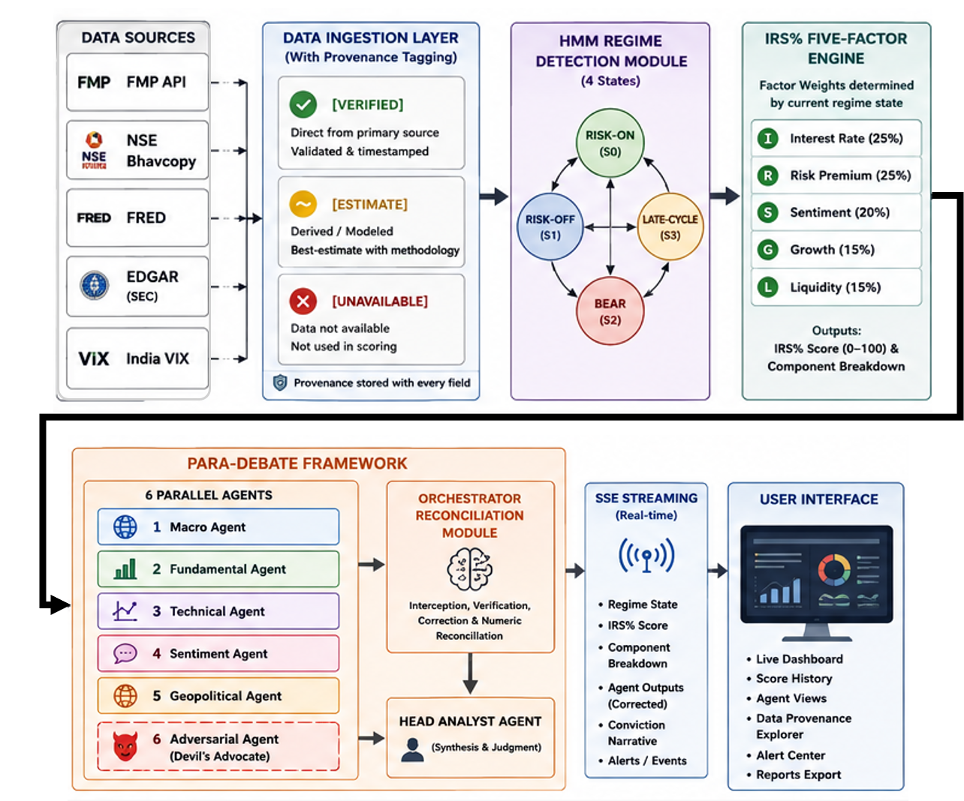

Figure 2, PARA-DEBATE Agent Interaction Flow
FIG. 2: Provenance-tagged data context 6 agents in parallel (Macro, Fundamental, Technical, Sentiment, Geopolitical, Adversarial) Orchestrator Reconciliation Module intercepts each agent output corrected outputs Head Analyst Agent Final IRS% Score + Investment Conviction Narrative. Adversarial agent visually differentiated.

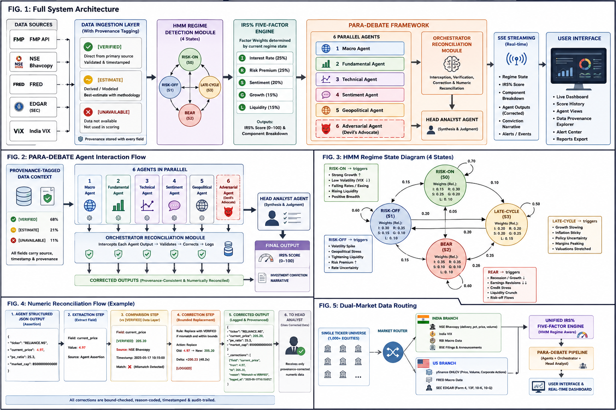

Figure 3, HMM Regime State Diagram
FIG. 3: State diagram with 4 nodes: Risk-On, Risk-Off, Bear, Late-Cycle. Transition probability arrows between states. For each state node, annotate relative factor weights. Example macro conditions triggering each state transition labelled.
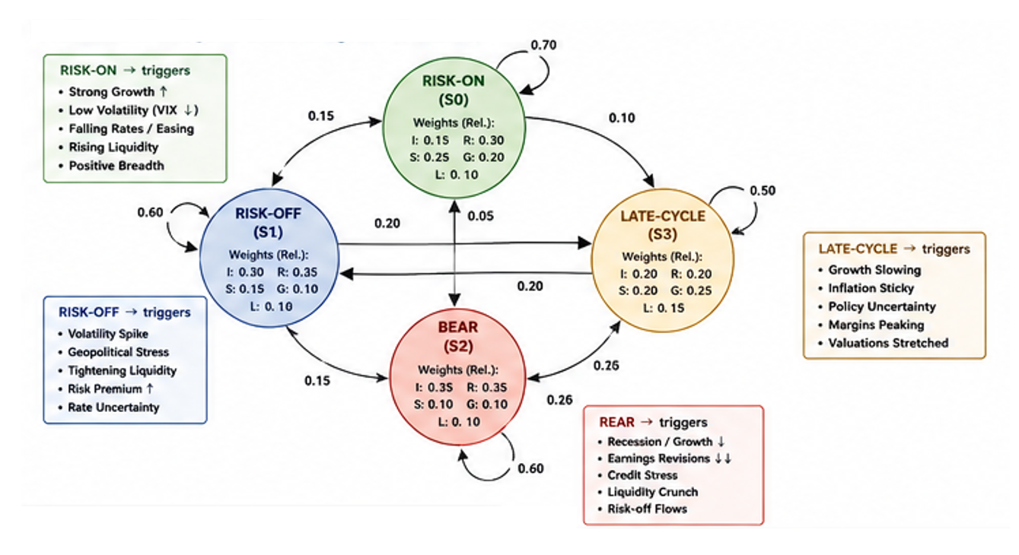

Figure 4, Numeric Reconciliation Flow (Example)
FIG. 4: Agent structured JSON output Extraction step Comparison step (vs [VERIFIED] data layer) Correction step (bounded replacement logged) Corrected output Head Analyst. Example: ‘current_price: 4.97 [agent assertion]’ ‘[VERIFIED]: 205.20’ ‘corrected: 205.20 [LOGGED]’.

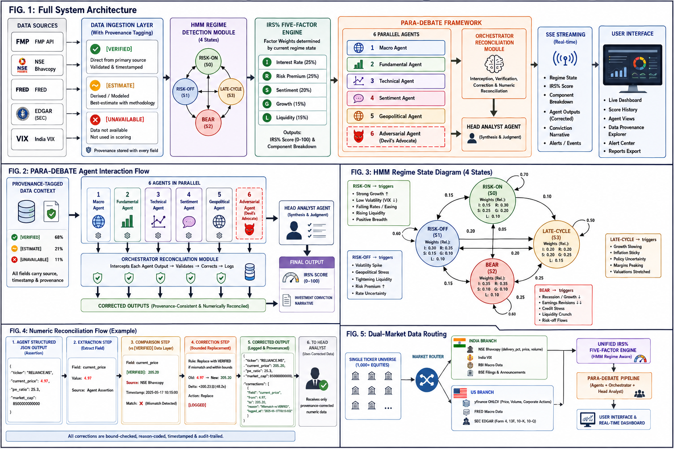
Figure 5, Dual-Market Data Routing
FIG. 5: Single ticker universe (1,000+ equities) Market router (India branch / US branch) India branch: NSE Bhavcopy delivery_pct, India VIX, RBI, BSE filings US branch: yfinance OHLCV, FRED macro, SEC EDGAR Form 4 Converge at unified IRS% engine and PARA-DEBATE pipeline.


4. COMMERCIAL & MARKET VIABILITY
4.1 Application, current and future products

Current commercial product | NeuralQuant V4.0: live at neuralquant.co. B2C SaaS platform providing AI-powered quantitative equity research to retail investors in India (NSE/BSE) and the United States (NYSE/NASDAQ). Named features: ‘Ask Morgan’ ForeCast, PARA-DEBATE deep-analysis, QuantAstra and Veronica voice assistants, Portfolio Intelligence module.
Subscription tiers (live) | Free (limited queries); Investor: USD 9.99/month / INR 499/month (full PARA-DEBATE output); Pro - USD 29.99/month / INR 999/month (full output + API access). Stripe payment infrastructure being activated.
B2B API (planned) | Developer API tier exposing the IRS% scoring engine and PARA-DEBATE output to third-party applications: fintech platforms, robo-advisors, SEBI-registered investment advisors (RIAs), PMS providers, wealth management platforms.
Adjacent markets | Australian retail investors; Southeast Asian markets (Malaysia, Singapore, Indonesia); university finance curriculum tools; investment club and community platforms.
Market size | TAM: USD 47B global retail fintech analytics market. SAM: USD 3.2B (India + US retail investors using AI tools). SOM 3-year: USD 48M (50,000 paying subscribers at USD 80/year blended ARPU).
Sale intent | The inventor intends to sell the platform, codebase, domain (neuralquant.co), brand, user base, social handles (@neuralquant), trademarks, and this patent application to a third-party acquirer. Patent assignment to buyer via Form 16 at IPO upon sale close. Realistic sale valuation: USD 50K–150K (patent pending, some revenue); USD 200K–500K+ with right strategic buyer.
4.2 Infringement Detectability
Thinking about your invention in the hands of a competitor, would it be possible to tell, from the outside, that they are using it? Which parts are observable in their product or output, and which are hidden in the backend?
Externally observable (method claims) | The 7-agent PARA-DEBATE structure is observable in the output: any competitor platform producing outputs in the same structured agent-narrative format (named agents, adversarial case, head analyst synthesis, IRS% score) would be identifiable. The IRS% score name and the adversarial agent’s explicitly labelled contribution are all visible in the user-facing output.
Backend / hidden (system claims) | The specific factor weights per regime state, the HMM transition probabilities, the specific agent prompt architecture, the NSE delivery_pct normalisation formula, the reconciliation bounded-correction thresholds, and the IRS% composite calculation formula are not externally visible and constitute trade secrets in addition to the patent protection.
Claim strategy: Both SYSTEM claims (the platform architecture, Components 1–7) and METHOD claims (the step-by-step process of regime detection factor scoring adversarial debate reconciliation synthesis) needs to be pursued. Method claims are particularly important as they are enforceable from observable output. System claims protect the architecture against backend cloning.

PARA-DEBATE trademark: The PARA-DEBATE name and IRS% methodology name needs to be registered as trademarks (Class 42, Software/SaaS/Technology Services) via Indian Trademark Registry simultaneously with the patent filing.

4.3 Development Stage
Concept only ☐ Design / Simulation ☐ Prototype built ☐ Tested & verified ☑
Tested & Verified — the system is in full commercial production deployment at neuralquant.co (Version 4.0). Q1 FY2027 backtesting completed showing 87%+ directional hit rate. Platform is operational with a live registered user base across free and paid tiers. Reconciliation module’s corrections are observable in production logs..

5. CONTRIBUTORS & LEGAL
5.1 Source of Resources
Was the invention developed using company equipment and time, personal resources, government-funded research, or a collaboration?
Company resources ☐ Personal ☑ Govt-funded ☐ Collaboration ☐

Hardware | Personally owned laptop and computing equipment exclusively. No university, employer, institutional, or company hardware used at any stage.
Cloud services | All personally funded: Vercel (frontend hosting), Render (backend hosting), Supabase (database and auth), Anthropic API (LLM backbone), Financial Modeling Prep API (market data), AWS Bedrock (LLM), Finnhub API (supplementary data). All accounts registered and paid personally by the inventor.
Financial funding | No government grant, university funding, employer funding, VC investment, or external capital received. Funded entirely from personal resources by the inventor.
University relationship | The inventor is a Masters of Artificial Intelligence student at the University of Technology Sydney (UTS), Australia (enrolled February 2026). NeuralQuant was NOT developed: as part of any UTS coursework; as part of any UTS thesis or supervised research project; using any UTS computing resources, labs, or institutional licences; with any UTS faculty intellectual contribution; under any UTS-funded programme. UTS has NO IP claim whatsoever over this invention.
Supporting declaration | An Independent Development Declaration has been signed and dated by the inventor (Satyam Das) confirming 100% sole personal development, independent of any university, employer, or third party. This declaration is available to Intepat on request and should be retained in the patent file.
Filing category | NATURAL PERSON — Individual Inventor. Form 28 (Declaration as to Status of Applicant) to be filed confirming natural person status.

5.2 Third-Party Rights
Does the invention rely on any pre-existing IP (yours or a third party's), open-source software with restrictive licences (GPL, AGPL, LGPL, MPL, SSPL), pre-trained AI models with non-commercial terms, pre-existing datasets with licence restrictions, third-party APIs, or standards that may be subject to SEP licensing?
☐☑ Yes ☐ No (detail below)
Anthropic Claude API / AWS Bedrock | Commercial API licence. The inventive system architecture (PARA-DEBATE + IRS% engine + reconciliation + dual-market pipeline) is fully independent of the specific LLM used. No licensing restriction on patenting or commercialising outputs.
Financial Modeling Prep (FMP) | Commercial data API licence. Primary US equity data source. No IP restriction on analytical outputs derived from FMP data.
OpenBB Platform | AGPL-v3 licence. ATTORNEY ACTION REQUIRED: Confirm that the process-boundary isolation (OpenBB deployed as a separate HTTP-proxied service with no AGPL code linked into the main NeuralQuant application) is legally sufficient to prevent AGPL copyleft contamination of the main application.
yfinance | Apache-2.0 licence. No restrictions.
hmmlearn / scikit-learn | BSD licence. No restrictions. Used for HMM training. No novel training methodology, inventive step is in the application architecture.
FastAPI / Next.js | MIT licence. No restrictions.
Supabase / PostgreSQL | Apache-2.0 / PostgreSQL licence. No restrictions.
DuckDB | MIT licence. No restrictions.
LiveKit | Apache-2.0 licence. No restrictions. Used for voice assistant feature.
ElevenLabs / Deepgram / Sarvam | Commercial speech APIs. No restriction on patenting the system that uses them.
NSE Bhavcopy data | Publicly distributed by National Stock Exchange of India for market transparency. No restrictive commercial licence on use for analysis or incorporation into a scoring system.
FRED / SEC EDGAR APIs | US government public domain. No restrictions.

5.3 Inventor Details
List every person who contributed to the conception of the invention. Indian and most foreign patent laws require ALL true inventors to be named. Omitting an inventor (or naming a non-inventor) can invalidate the patent.
Role | Full Name | Nationality | Contribution % | Email & Phone | Address
Sole Inventor & Applicant | Satyam Das | Indian | 100% | satyamdas03@gmail.com  +61 412 342 026 | Current: 483 Wattle Street, Ultimo NSW 2007, Australia  Indian: D11.5, NBCC Vibgyor Towers, Action Area-1, New Town, Kolkata - 700156
(Add rows as needed, right-click on the last row → Insert → Rows Below.)
5.4 Applicant Details, patent owner
The applicant is the entity that will own the patent. This may be a company (if the invention was developed in the course of employment), the inventor(s) themselves, or a combination.
Applicant (full name) | Nationality / Country of incorporation | Address
Satyam Das (Individual Natural Person) | Indian National | D11.5, NBCC Vibgyor Towers, Action Area-1, New Town, Kolkata - 700156  Note: Inventor is an international student, pursuing his Masters in Australia and currently residing in Sydney, Australia. All documents may be executed electronically and returned by email. Intepat to manage all in-person IPO interactions.

6. TECHNOLOGY-SPECIFIC REMINDERS (OPTIONAL)
Depending on your invention type, certain details are commonly overlooked. Review the list that matches your domain and ensure the relevant information is captured in Section 3. This appendix is a checklist, not a set of fields to fill.

Model architecture | Seven-agent adversarial debate framework (PARA-DEBATE). LLM agents using role-specific chain-of-thought prompting. HMM (4-state) for market regime detection. Five-factor cross-sectional scoring engine with regime-adaptive weights. Numeric reconciliation orchestrator (deterministic post-processing). Novel elements: adversarial agent architecture, regime-adaptive dynamic factor weighting, dual-market data routing with India-specific NSE delivery_pct signal.
Training data | HMM trained on: rolling 6-month daily OHLCV price data, FRED macro indicators, India VIX, US VIX. Source: publicly available market APIs. Separate models for India and US markets. No proprietary training datasets. No personally identifiable data.
Pre-trained models | Anthropic Claude API (claude-sonnet-4-6) — commercial API licence, no non-commercial restrictions on analytical outputs. hmmlearn — BSD licence. scikit-learn — BSD licence. No pre-trained financial domain models with non-commercial restrictions.
Training methodology | HMM: Baum-Welch EM algorithm on rolling macro/price feature windows. Standard methodology (Hamilton 1989). No novel training algorithm — the inventive step is in the architectural application of the trained HMM to dynamic factor reweighting, not in the training method itself.
Evaluation metrics | IRS% scoring directional hit rate: 87%+ for top-quintile equities vs. benchmark (Q1 FY2027, live data, no look-ahead bias). IC (Information Coefficient) and ICIR to be quantified and inserted before complete specification filing. Sharpe ratio of top-quintile vs. index to be provided. Reconciliation module: correction rate (N corrections per M analyses) to be measured and documented.
Inference pipeline | FastAPI Python backend. Real-time inference at query time. Anthropic/AWS Bedrock API for LLM agent calls via asyncio.gather() (parallel). SSE streaming to Next.js frontend. Target latency: 30–120 seconds complete PARA-DEBATE output. Cloud-hosted CPU instances (Render.com). No GPU required at inference time.

FOR INTERNAL USE ONLY, ATTORNEY / REVIEWER
Completed by the Intepat patent agent on receipt. Not filled by the inventor.
Date Received: | IDF Reference:
NDA Reference: | Assigned Patent Agent:
Jurisdictions of Interest: | Review Priority (High / Medium / Low):

Recommendation
File Provisional File Complete Trade Secret Do Not File Further Discussion Needed
Reviewer notes, patentability assessment, 3(k)/3(d)/3(i) analysis, claim strategy, risks
Attorney's internal analysis, not shared with the inventor.

Inventor Signature  Name: Satyam Das  Date: 18 Jun 2026  Place: Sydney, Australia | Patent Agent Signature  Name: ____________________________  Date: ____________________________  Place: ____________________________

